BÀI THỰC HÀNH 2

TRẦN VĂN QUYỀN

MSSV: 19574802010166

Câu 1:

import cv2

img = cv2.imread('D:\Tran Quyen\Document\Image\quyen.png')

alpha = 0

def get_alpha(pos):

global alpha

alpha = pos

beta = 0

def get_beta(pos):

global beta

beta = pos

cv2.namedWindow('Image')

cv2.resizeWindow('Image', 500, 100)

cv2.createTrackbar('Tuong phan','Image',0,3,get_alpha)

cv2.createTrackbar('Do sang','Image',0,100,get_beta)

while True:

output = cv2.convertScaleAbs(img,alpha = alpha, beta = beta)

cv2.imshow('IMG',output)

if cv2.waitKey(10) == ord('s'):

cv2.imwrite("cau1.png", output)

if cv2.waitKey(10) == ord('q'):

break

cv2.destroyAllWindows()

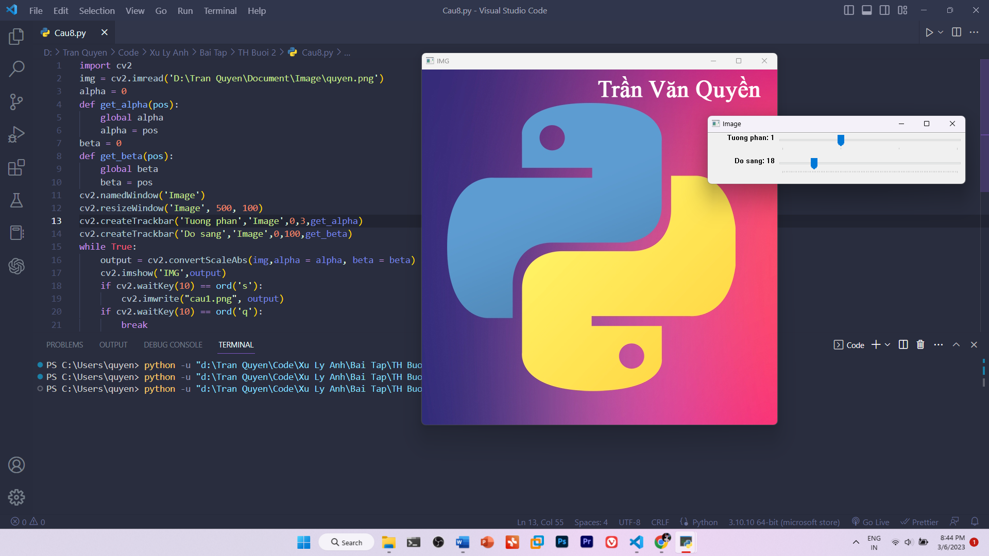

Câu 2:

import cv2

img = cv2.imread('D:\Tran Quyen\Document\Image\quyen.png')

[w,h] = img.shape[:2]

img_am_ban = img

a = 0

img_gray = cv2.cvtColor(img, cv2.COLOR_BGR2GRAY )

def convert_to_binary(pos):

global a

a = pos

gray_img = cv2.cvtColor(img, cv2.COLOR_BGR2GRAY )

cv2.namedWindow('Anh')

cv2.resizeWindow('Anh', 500, 100)

cv2.createTrackbar('Nhi Phan', 'Anh', 1,127,convert_to_binary)

while True:

ret, binaryimg = cv2.threshold(gray_img, a, 255, cv2.THRESH_BINARY)

cv2.imshow('Anh', binaryimg)

if cv2.waitKey(10) == ord('s'):

cv2.imwrite("anh-nhi-phan.png", binaryimg )

if cv2.waitKey(10) == ord('a'):

for i in range (w):

for j in range (h):

img_am_ban[i][j] = 255 - img[i][j]

cv2.imwrite("Am_ban.png", img_am_ban )

if cv2.waitKey(10) == ord('q'):

break

cv2.destroyAllWindows()

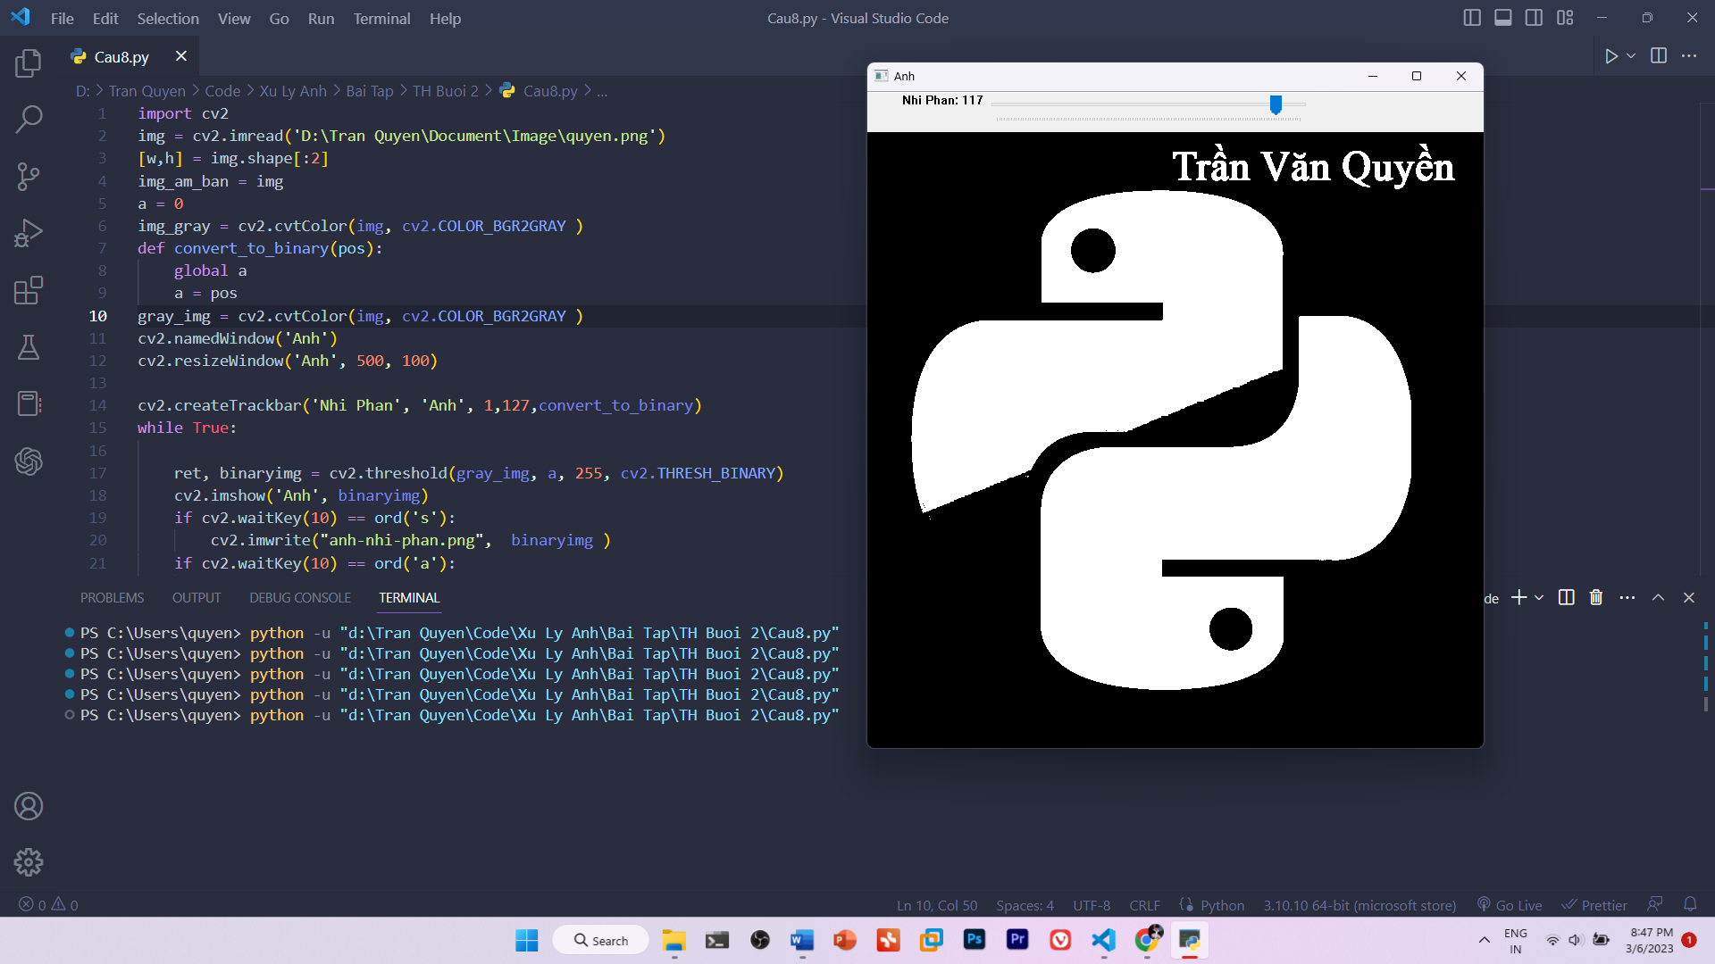

Câu 3:

import cv2

img = cv2.imread('D:\Tran Quyen\Document\Image\quyen.png')

alpha = 0

def get_alpha(pos):

global alpha

alpha = pos

beta = 0

def get_beta(pos):

global beta

beta = pos

cv2.namedWindow('show')

cv2.resizeWindow('show', 500, 100)

cv2.createTrackbar('FX','show',1,4,get_alpha)

cv2.createTrackbar('FY','show',1,4,get_beta)

while True:

output = cv2.resize(img, None,fx=0.5*alpha,fy= 0.5*beta, interpolation=cv2.INTER_LINEAR)

cv2.imshow('anh',output)

if cv2.waitKey(10) == ord('q'):

break

cv2.destroyAllWindows()

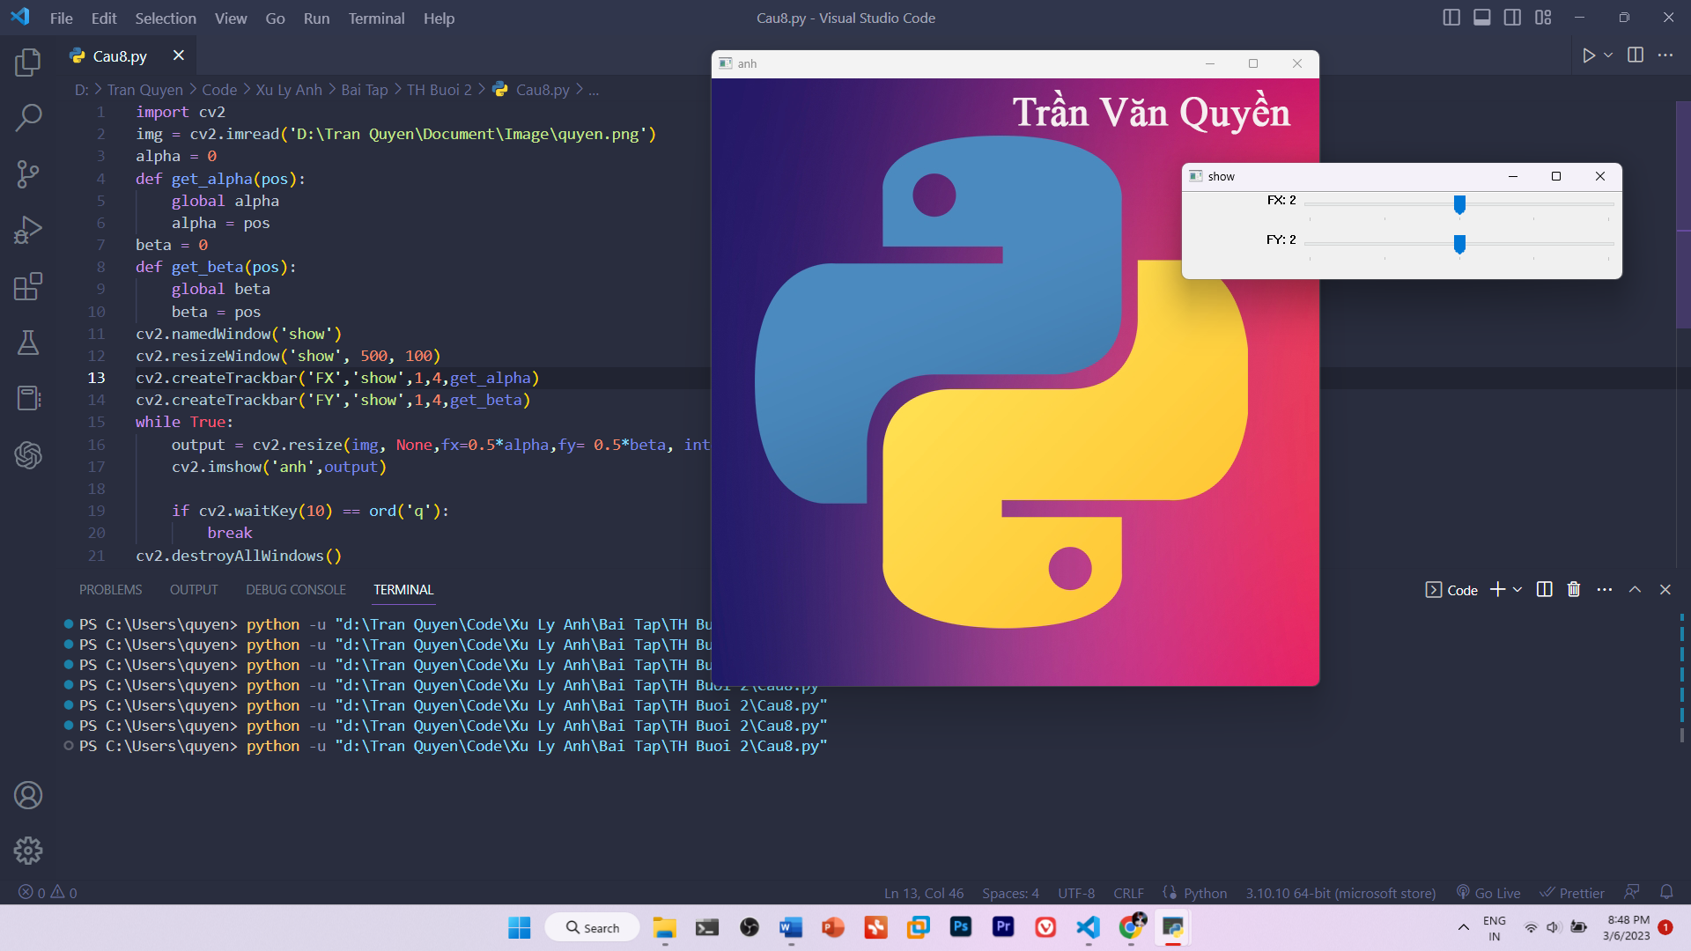

Câu 4:

import cv2

img = cv2.imread('D:\Tran Quyen\Document\Image\quyen.png')

w = int(input('Nhap chieu rong: '))

h = int(input('Nhap chieu cao: '))

img_by_wh = img[0:w, 0:h]

cv2.imshow('cat anh theo chieu dai, chieu rong', img_by_wh)

cv2.waitKey(0)

cv2.destroyAllWindows()

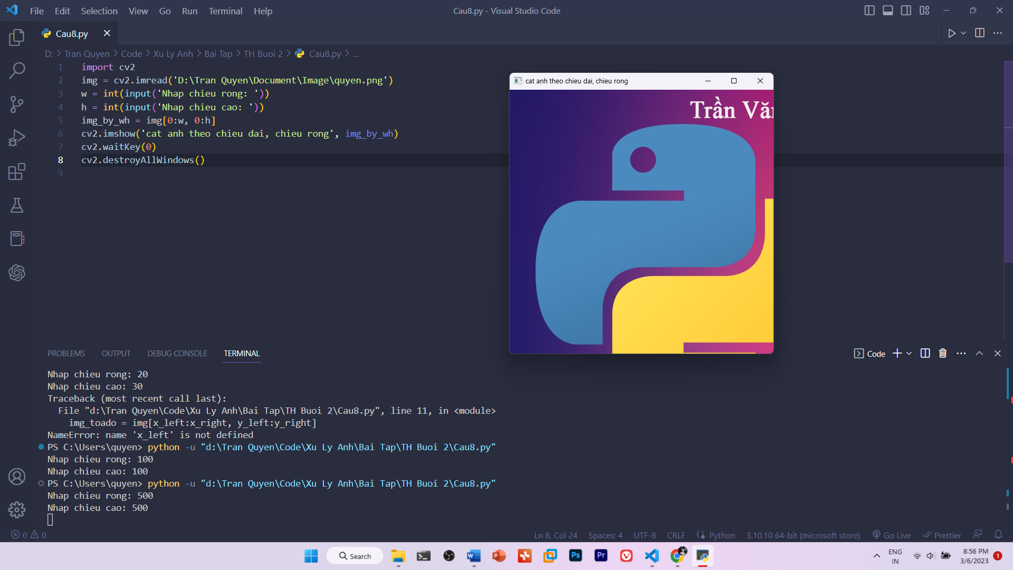

Câu 5:

import cv2

import numpy as np

img = cv2.imread('D:\Tran Quyen\Document\Image\quyen.png')

(rows, cols) = img.shape[:2]

tx = 0

def set_tx(pos):

global tx

tx = pos

ty = 0

def set_ty(pos):

global ty

ty = pos

cv2.namedWindow('show')

cv2.resizeWindow('show', 500, 100)

cv2.createTrackbar('TX','show',1,200, set_tx)

cv2.createTrackbar('TY','show',1,200, set_ty)

while True:

M1 = np.array([[1, 0, tx], [0, 1, ty]], dtype=np.float32)

tran1 = cv2.warpAffine(img, M1, (cols, rows))

cv2.imshow('anh',tran1)

if cv2.waitKey(10) == ord('q'):

break

cv2.destroyAllWindows()

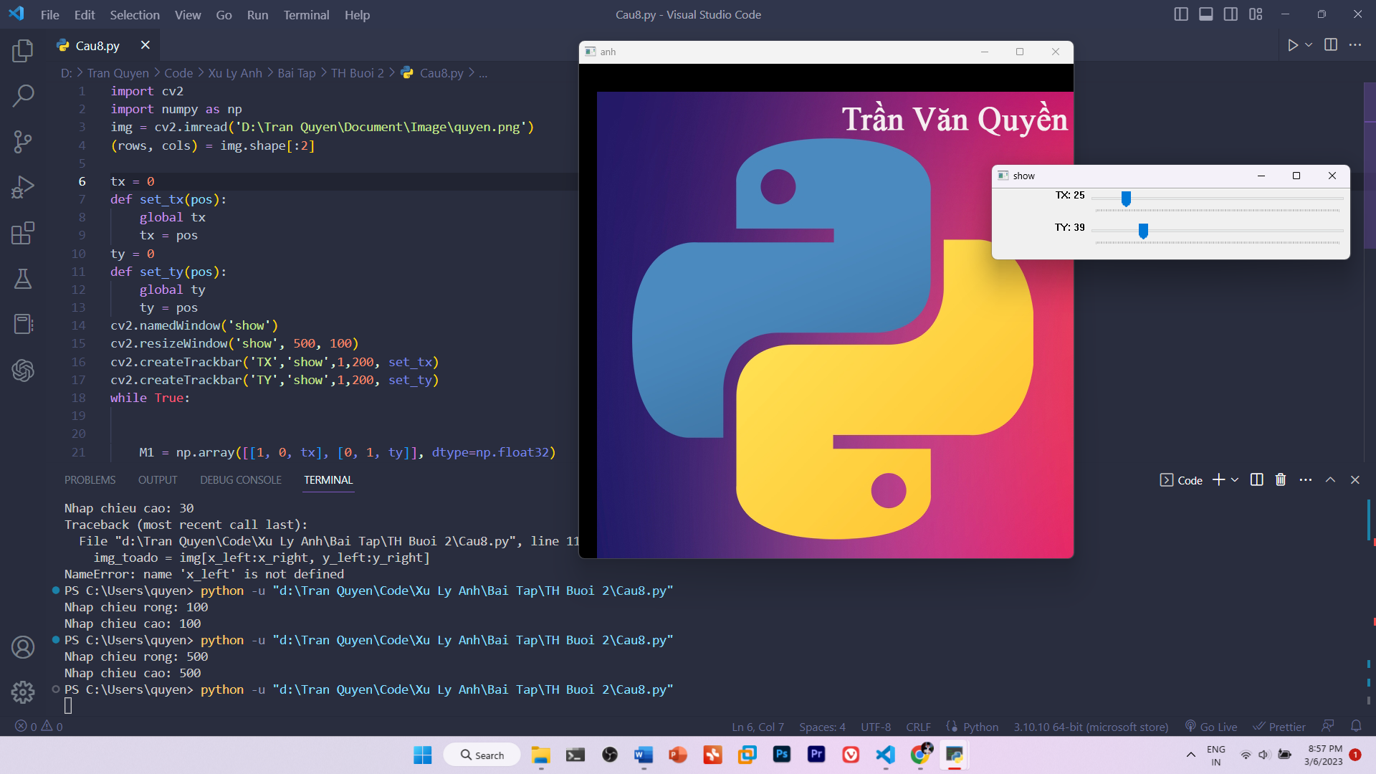

Câu 6:

import cv2

img = cv2.imread('D:\Tran Quyen\Document\Image\quyen.png')

(rows, cols) = img.shape[:2]

alpha = 0

def set_alpha(pos):

global alpha

alpha = pos

cv2.namedWindow('show')

cv2.resizeWindow('show', 500, 100)

cv2.createTrackbar('goc quay','show',0,360, set_alpha)

while True:

M = cv2.getRotationMatrix2D(center = (cols/2,rows/2), angle=alpha, scale=1)

ro = cv2.warpAffine(img, M, (cols, rows))

cv2.imshow('anh',ro)

if cv2.waitKey(10) == ord('q'):

break

cv2.destroyAllWindows()

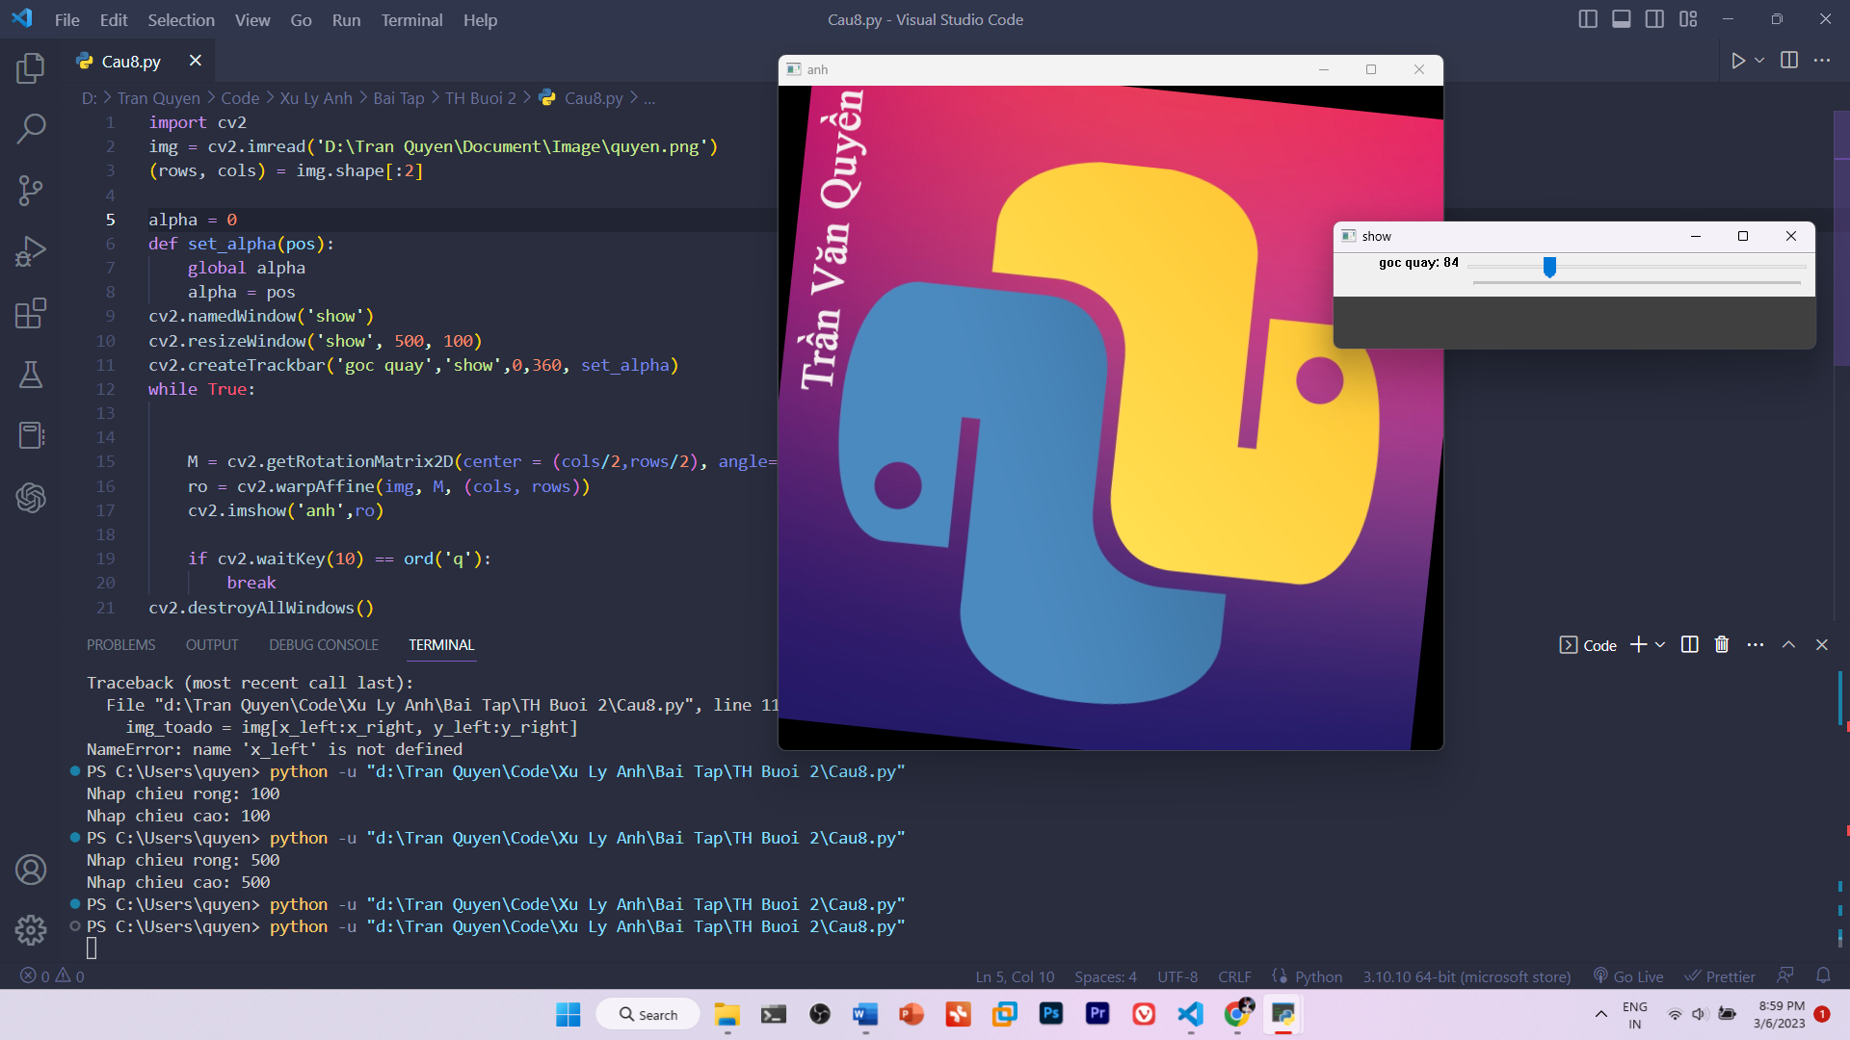

Câu 7:

import cv2

import numpy as np

img = cv2.imread("D:\Tran Quyen\Document\Image\quyen.png")

pts1 = np.float32([[170,2],[668,6],[100,338],[639,397]])

pts2 = np.float32([[0,0],[210,0],[0,297],[210,297]])

M = cv2.getPerspectiveTransform(pts1,pts2)

dst = cv2.warpPerspective(img,M,(210,297))

cv2.imshow("results", dst)

cv2.imshow('image', img)

cv2.waitKey(0)

cv2.destroyAllWindows()

